ARDUINO

INTRODUCTION
The ATmega328P is a low-power CMOS 8-bit microcontroller based on the AVR enhanced RISC architecture. By executing powerful instructions in a single clock cycle, the ATmega328P achieves throughputs approaching 1 MIPS per MHz allowing the system designer to optimize power consumption versus processing speed.

PIN DETAILS
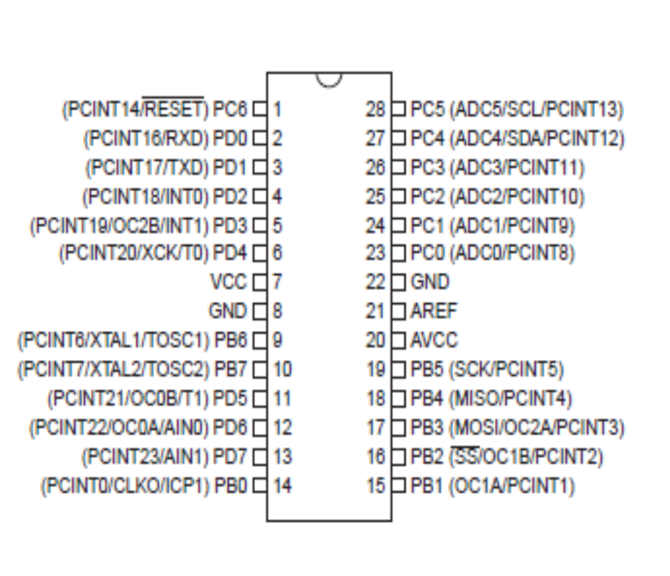

1.1 Pin Descriptions

1.1.1 VCC
Digital supply voltage.

1.1.2 GND
Ground.

1.1.3 Port B (PB7:0) XTAL1/XTAL2/TOSC1/TOSC2
Port B is an 8-bit bi-directional I/O port with internal pull-up resistors (selected for each bit). The Port B output buffers have symmetrical drive characteristics with both high sink and source capability. As inputs, Port B pins that are externally pulled low will source current if the pull-up resistors are activated. The Port B pins are tri-stated when a reset condition becomes active, even if the clock is not running.

Depending on the clock selection fuse settings, PB6 can be used as input to the inverting Oscillator amplifier and input to the internal clock operating circuit. Depending on the clock selection fuse settings, PB7 can be used as output from the inverting Oscillator amplifier.

If the Internal Calibrated RC Oscillator is used as chip clock source, PB7..6 is used as TOSC2..1 input for the Asynchronous Timer/Counter2 if the AS2 bit in ASSR is set.

1.1.4 Port C (PC5:0)
Port C is a 7-bit bi-directional I/O port with internal pull-up resistors (selected for each bit). The PC5..0 output buffers have symmetrical drive characteristics with both high sink and source capability. As inputs, Port C pins that are externally pulled low will source current if the pull-up resistors are activated. The Port C pins are tri-stated when a reset condition becomes active, even if the clock is not running.

1.1.5 PC6/RESET
If the RSTDISBL Fuse is programmed, PC6 is used as an I/O pin. Note that the electrical characteristics of PC6 differ from those of the other pins of Port C. If the RSTDISBL Fuse is unprogrammed, PC6 is used as a Reset input. A low level on this pin for longer than the minimum pulse length will generate a Reset, even if the clock is not running.

1.1.6 Port D (PD7:0)
Port D is an 8-bit bi-directional I/O port with internal pull-up resistors (selected for each bit). The Port D output buffers have symmetrical drive characteristics with both high sink and source capability. As inputs, Port D pins that are externally pulled low will source current if the pull-up resistors are activated. The Port D pins are tri-stated when a reset condition becomes active, even if the clock is not running.

1.1.7 AVCC
AVCC is the supply voltage pin for the A/D Converter, PC3:0, and ADC7:6. It should be externally connected to VCC, even if the ADC is not used. If the ADC is used, it should be connected to VCC through a low-pass filter. Note that PC6..4 use digital supply voltage, VCC.

1.1.8 AREF
AREF is the analog reference pin for the A/D Converter.

BLOCK DIAGRAM:
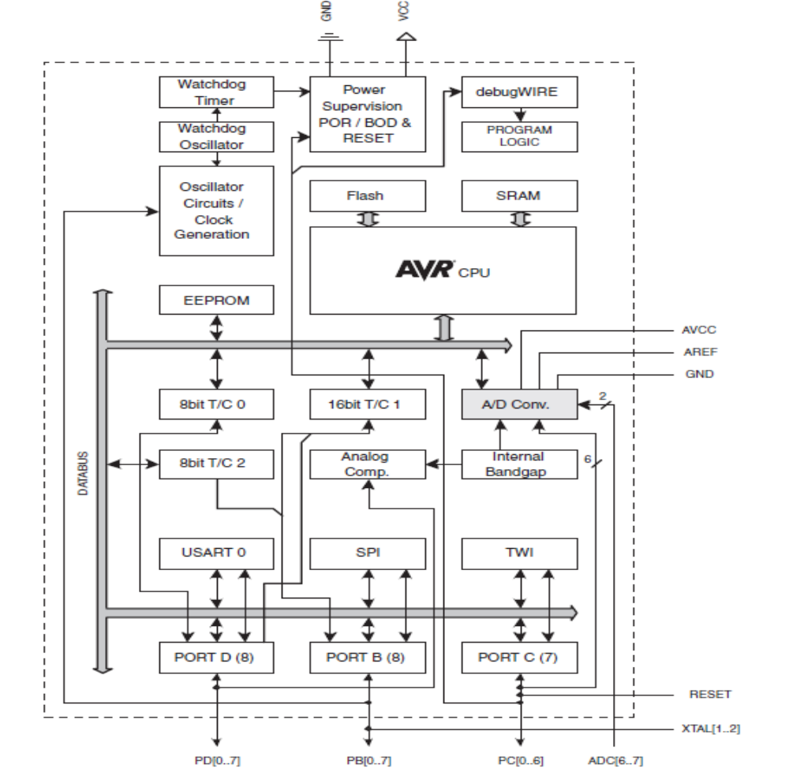

The AVR core combines a rich instruction set with 32 general purpose working registers. All the32 registers are directly connected to the Arithmetic Logic Unit (ALU), allowing two independent registers to be accessed in one single instruction executed in one clock cycle. The resulting architecture is more code efficient while achieving throughputs up to ten times faster than conventional CISC microcontrollers.

The ATmega328P provides the following features: 4K/8K bytes of In-System
Programmable Flash with Read-While-Write capabilities, 1K bytes EEPROM, 2K bytes SRAM, 23 general purpose I/O lines, 32 general purpose working registers,
three flexible Timer/Counters with compare modes, internal and external interrupts, a serial programmable USART, a byte-oriented 2-wire Serial Interface, an SPI serial port, a 6-channel 10-bit ADC (8 channels in TQFP and QFN/MLF packages), a programmable Watchdog Timer with internal Oscillator, and five software selectable power saving modes. The Idle mode stops the CPU while allowing the SRAM, Timer/Counters, USART, 2-wire Serial Interface, SPI port, and interrupt system to continue functioning. The Power-down mode saves the register contents but freezes the Oscillator, disabling all other chip functions until the next interrupt or hardware reset. In Power-save mode, the asynchronous timer continues to run, allowing the user to maintain a timer base while the rest of the device is sleeping. The ADC Noise Reduction mode stops the CPU and all I/O modules except asynchronous timer and ADC, to minimize switching noise during
ADC conversions. In Standby mode, the crystal/resonator Oscillator is running while the rest of the device is sleeping. This allows very fast start-up combined with low power consumption.

The device is manufactured using Atmel’s high density non-volatile memory technology. The On-chip ISP Flash allows the program memory to be reprogrammed In-System through an SPI serial interface, by a conventional non-volatile memory programmer, or by an On-chip Boot program running on the AVR core. The Boot program can use any interface to download the application program in the Application Flash memory. Software in the Boot Flash section will continue to run while the Application Flash section is updated, providing true Read-While Write operation. By combining an 8-bit RISC CPU with In-System Self-Programmable Flash on a monolithic chip, the Atmel ATmega328P is a powerful microcontroller that provides a highly flexible and cost effective solution to many embedded control applications.

The ATmega328P AVR is supported with a full suite of program and system development tools including: C Compilers, Macro Assemblers, Program Debugger/Simulators, In-Circuit Emulators, and Evaluation kits.

AVR CPU Core
Overview
This section discusses the AVR core architecture in general. The main function of the CPU core is to ensure correct program execution. The CPU must therefore be able to access memories, perform calculations, control peripherals, and handle interrupts.
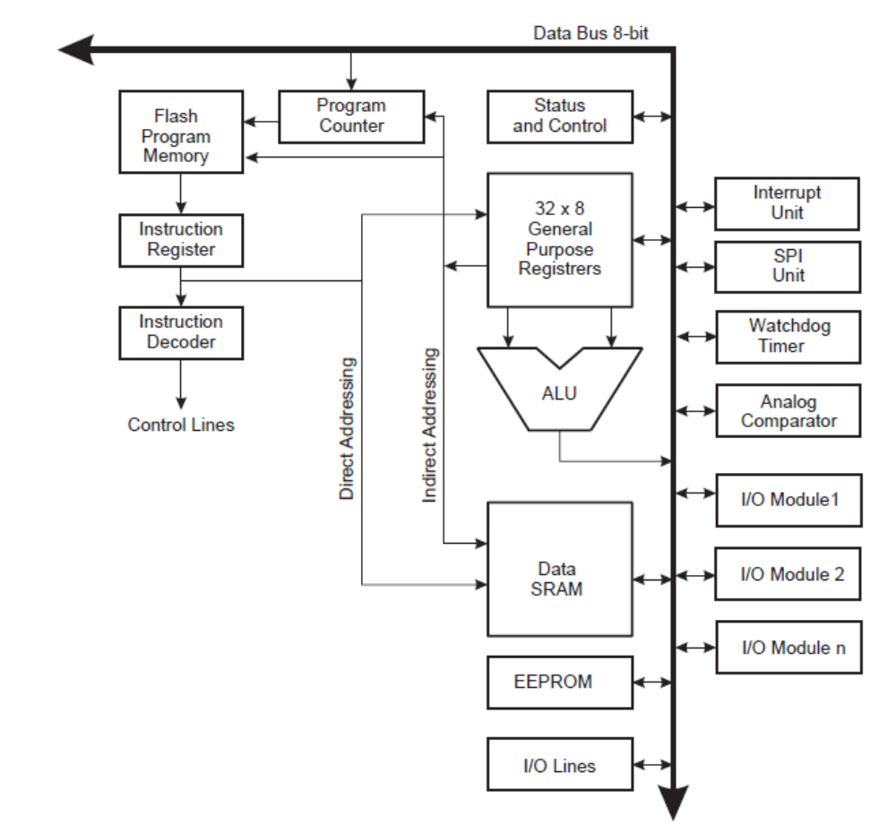

In order to maximize performance and parallelism, the AVR uses a Harvard architecture – with separate memories and buses for program and data. Instructions in the program memory are executed with a single level pipelining. While one instruction is being executed, the next instruction is pre-fetched from the program memory. This concept enables instructions to be executed in every clock cycle. The program memory is In-System Reprogrammable Flash memory. The fast-access Register File contains 32 x 8-bit general purpose working registers with a single clock cycle access time. This allows single-cycle Arithmetic Logic Unit (ALU) operation. In a typical ALU operation, two operands are output from the Register File, the operation is executed, and the result is stored back in the Register File – in one clock cycle.

Six of the 32 registers can be used as three 16-bit indirect address register pointers for Data Space addressing – enabling efficient address calculations. One of the these address pointers can also be used as an address pointer for look up tables in Flash program memory. These added function registers are the 16-bit X-, Y-, and Z-register, described later in this section. The ALU supports arithmetic and logic operations between registers or between a constant and a register. Single register operations can also be executed in the ALU. After an arithmetic operation,
the Status Register is updated to reflect information about the result of the operation. Program flow is provided by conditional and unconditional jump and call instructions, able to directly address the whole address space. Most AVR instructions have a single 16-bit word format. Every program memory address contains a 16- or 32-bit instruction. Program Flash memory space is divided in two sections, the Boot Program section and the Application Program section. Both sections have dedicated Lock bits for write and read/write protection. The SPM instruction that writes into the Application Flash memory section must reside in the Boot Program section.

During interrupts and subroutine calls, the return address Program Counter (PC) is stored on the Stack. The Stack is effectively allocated in the general data SRAM, and consequently the Stack size is only limited by the total SRAM size and the usage of the SRAM. All user programs must initialize the SP in the Reset routine (before subroutines or interrupts are executed). The Stack Pointer (SP) is read/write accessible in the I/O space. The data SRAM can easily be accessed through the five different addressing modes supported in the AVR architecture. The memory spaces in the AVR architecture are all linear and regular memory maps.

A flexible interrupt module has its control registers in the I/O space with an additional Global Interrupt Enable bit in the Status Register. All interrupts have a separate Interrupt Vector in the Interrupt Vector table. The interrupts have priority in accordance with their Interrupt Vector position. The lower the Interrupt Vector address, the higher the priority.

The I/O memory space contains 64 addresses for CPU peripheral functions as Control Registers, SPI, and other I/O functions. The I/O Memory can be accessed directly, or as the Data Space locations following those of the Register File, 0x20 - 0x5F. In addition, the ATmega328P has Extended I/O space from 0x60 - 0xFF in SRAM where only the ST/STS/STD and LD/LDS/LDD instructions can be used.

ALU – Arithmetic Logic Unit
The high-performance AVR ALU operates in direct connection with all the 32 general purpose working registers. Within a single clock cycle, arithmetic operations between general purpose registers or between a register and an immediate are executed. The ALU operations are divided into three main categories – arithmetic, logical, and bit-functions. Some implementations of the architecture also provide a powerful multiplier supporting both signed/unsigned multiplication and fractional format. See the “Instruction Set” section for a detailed description.

Status Register
The Status Register contains information about the result of the most recently executed arithmetic instruction. This information can be used for altering program flow in order to perform conditional operations. Note that the Status Register is updated after all ALU operations, as specified in the Instruction Set Reference. This will in many cases remove the need for using the dedicated compare instructions, resulting in faster and more compact code. The Status Register is not automatically stored when entering an interrupt routine and restored when returning from an interrupt. This must be handled by software.

SREG – AVR Status Register
The AVR Status Register – SREG – is defined as:
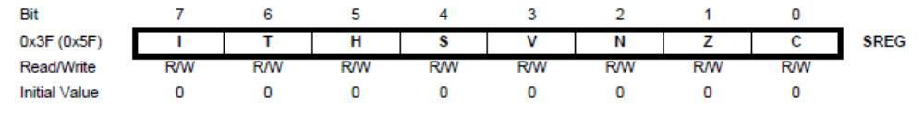

• Bit 7 – I: Global Interrupt Enable
The Global Interrupt Enable bit must be set for the interrupts to be enabled. The individual interrupt enable control is then performed in separate control registers. If the Global Interrupt Enable Register is cleared, none of the interrupts are enabled independent of the individual interrupt enable settings. The I-bit is cleared by hardware after an interrupt has occurred, and is set by the RETI instruction to enable subsequent interrupts. The I-bit can also be set and cleared by the application with the SEI and CLI instructions, as described in the instruction set reference.

• Bit 6 – T: Bit Copy Storage
The Bit Copy instructions BLD (Bit LoaD) and BST (Bit STore) use the T-bit as source or destination for the operated bit. A bit from a register in the Register File can be copied into T by the BST instruction, and a bit in T can be copied into a bit in a register in the Register File by the BLD instruction.

• Bit 5 – H: Half Carry Flag
The Half Carry Flag H indicates a Half Carry in some arithmetic operations. Half Carry Is useful in BCD arithmetic.

• Bit 4 – S: Sign Bit, S = N ⊕ V
The S-bit is always an exclusive or between the Negative Flag N and the Two’s Complement Overflow Flag V.

• Bit 3 – V: Two’s Complement Overflow Flag
The Two’s Complement Overflow Flag V supports two’s complement arithmetics.

• Bit 2 – N: Negative Flag
The Negative Flag N indicates a negative result in an arithmetic or logic operation.

• Bit 1 – Z: Zero Flag
The Zero Flag Z indicates a zero result in an arithmetic or logic operation.

• Bit 0 – C: Carry Flag
The Carry Flag C indicates a carry in an arithmetic or logic operation

General Purpose Register File
The Register File is optimized for the AVR Enhanced RISC instruction set. In order to achieve the required performance and flexibility, the following input/output schemes are supported by the Register File:
• One 8-bit output operand and one 8-bit result input
• Two 8-bit output operands and one 8-bit result input
• Two 8-bit output operands and one 16-bit result input
• One 16-bit output operand and one 16-bit result input

AVR CPU General Purpose Working Registers
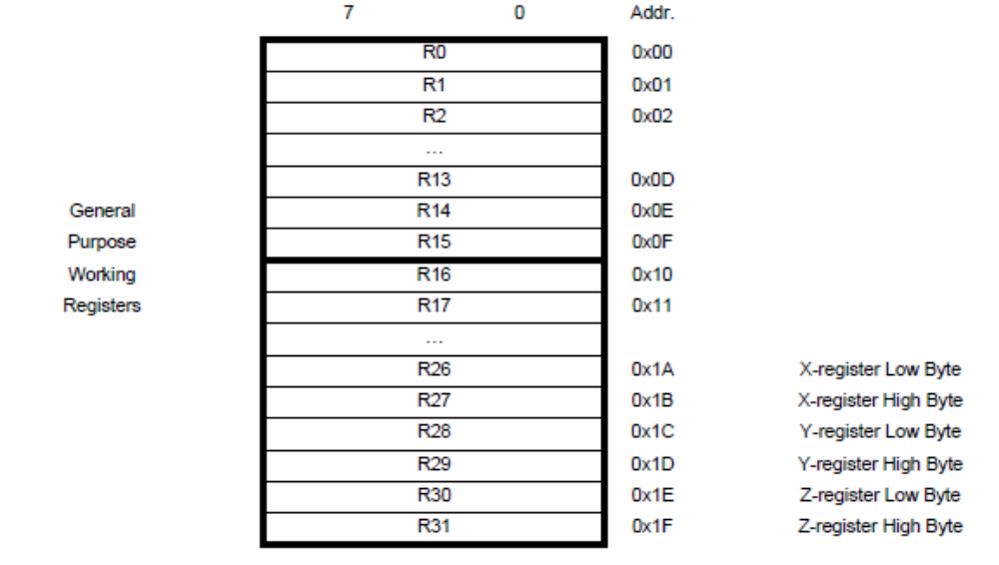
Most of the instructions operating on the Register File have direct access to all registers, and most of them are single cycle instructions. As shown in figure each register is also assigned a data memory address, mapping them directly into the first 32 locations of the user Data Space. Although not being physically implemented as SRAM locations, this memory organization provides great flexibility in access of the registers, as the X-, Y- and Z-pointer registers can be set to index any register in the file.

The X-register, Y-register, and Z-register
The registers R26..R31 have some added functions to their general purpose usage. These registers are 16-bit address pointers for indirect addressing of the data space. The three indirect address registers X, Y, and Z are defined as described in Figure.
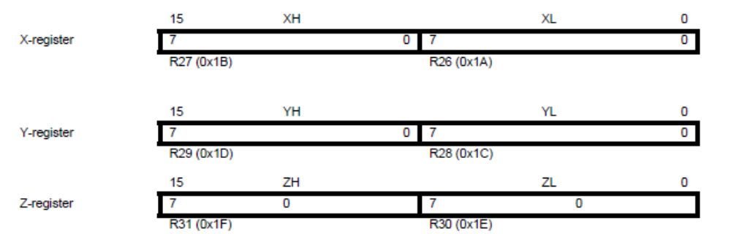
In the different addressing modes these address registers have functions as fixed displacement, automatic increment, and automatic decrement (see the instruction set reference for details).

Stack Pointer
The Stack is mainly used for storing temporary data, for storing local variables and for storing return addresses after interrupts and subroutine calls. Note that the Stack is implemented as growing from higher to lower memory locations. The Stack Pointer Register always points to the top of the Stack. The Stack Pointer points to the data SRAM Stack area where the Subroutine and Interrupt Stacks are located. A Stack PUSH command will decrease the Stack Pointer. The Stack in the data SRAM must be defined by the program before any subroutine calls are executed or interrupts are enabled. Initial Stack Pointer value equals the last address of the internal SRAM and the Stack Pointer must be set to point above start of the SRAM.

Stack pointer details
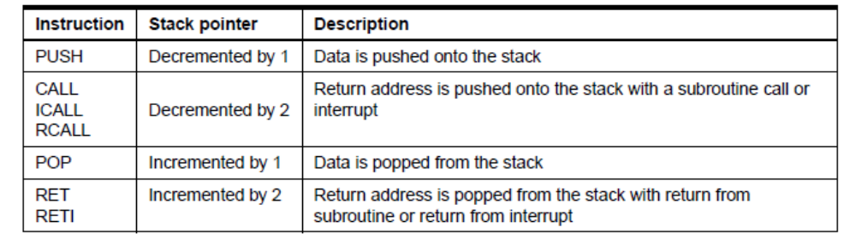
The AVR Stack Pointer is implemented as two 8-bit registers in the I/O space. The number of bits actually used is implementation dependent. Note that the data space in some implementations of the AVR architecture is so small that only SPL is needed. In this case, the SPH Register will not be present.

SPH and SPL – Stack Pointer High and Stack Pointer Low Register
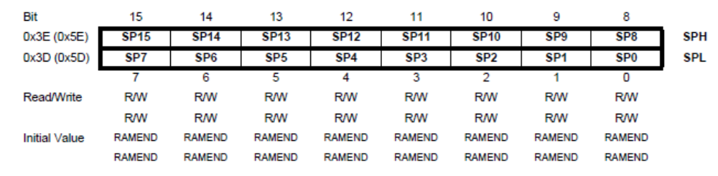
Instruction Execution Timing
This section describes the general access timing concepts for instruction execution. The AVR CPU is driven by the CPU clock clk CPU, directly generated from the selected clock source for the chip. No internal clock division is used. The figure shows the parallel instruction fetches and instruction executions enabled by the Harvard architecture and the fast-access Register File concept. This is the basic pipelining concept to obtain up to 1 MIPS per MHz with the corresponding unique results for functions per cost, functions per clocks, and functions per power-unit.

Figure . The Parallel Instruction Fetches and Instruction Executions
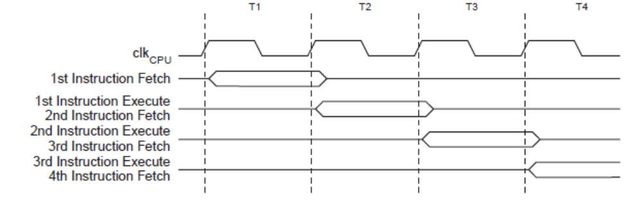
The below figure shows the internal timing concept for the Register File. In a single clock cycle an ALU operation using two register operands is executed, and the result is stored back to the destination register.

Figure . Single Cycle ALU Operation
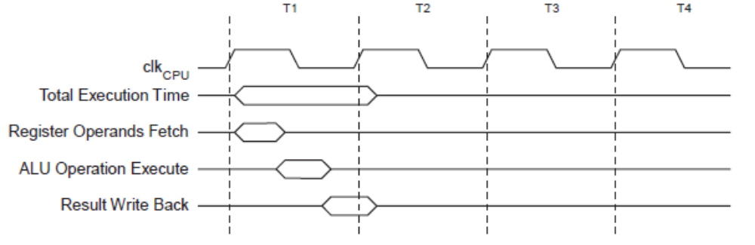

Reset and Interrupt Handling
The AVR provides several different interrupt sources. These interrupts and the separate Reset Vector each have a separate program vector in the program memory space. All interrupts are assigned individual enable bits which must be written logic one together with the Global Interrupt Enable bit in the Status Register in order to enable the interrupt. Depending on the Program Counter value, interrupts may be automatically disabled when Boot Lock bits BLB02 or BLB12 are programmed. This feature improves software security.

The lowest addresses in the program memory space are by default defined as the Reset and Interrupt Vectors. The list also determines the priority levels of the different interrupts. The lower the address the higher is the priority level. RESET has the highest priority, and next is INT0 – the External Interrupt Request 0. The Interrupt Vectors can be moved to the start of the Boot Flash section by setting the IVSEL bit in the MCU Control Register (MCUCR). The Reset Vector can also be moved to the start of the Boot Flash section by programming the BOOTRST Fuse

When an interrupt occurs, the Global Interrupt Enable I-bit is cleared and all interrupts are disabled. The user software can write logic one to the I-bit to enable nested interrupts. All enabled interrupts can then interrupt the current interrupt routine. The I-bit is automatically set when a Return from Interrupt instruction – RETI – is executed. There are basically two types of interrupts. The first type is triggered by an event that sets the Interrupt Flag. For these interrupts, the Program Counter is vectored to the actual Interrupt Vector in order to execute the interrupt handling routine, and hardware clears the corresponding Interrupt Flag. Interrupt Flags can also be cleared by writing a logic one to the flag bit position(s) to be cleared. If an interrupt condition occurs while the corresponding interrupt enable bit is cleared, the Interrupt Flag will be set and remembered until the interrupt is enabled, or the flag is cleared by software. Similarly, if one or more interrupt conditions occur while the Global Interrupt Enable bit is cleared, the corresponding Interrupt Flag(s) will be set and remembered until the Global Interrupt Enable bit is set, and will then be executed by order of priority.

The second type of interrupts will trigger as long as the interrupt condition is present. These interrupts do not necessarily have Interrupt Flags. If the interrupt condition disappears before the interrupt is enabled, the interrupt will not be triggered.

When the AVR exits from an interrupt, it will always return to the main program and execute one more instruction before any pending interrupt is served.

Note that the Status Register is not automatically stored when entering an interrupt routine, nor restored when returning from an interrupt routine. This must be handled by software. When using the CLI instruction to disable interrupts, the interrupts will be immediately disabled. No interrupt will be executed after the CLI instruction, even if it occurs simultaneously with the CLI instruction. The following example shows how this can be used to avoid interrupts during the timed EEPROM write sequence

Interrupt Response Time
The interrupt execution response for all the enabled AVR interrupts is four clock cycles minimum. After four clock cycles the program vector address for the actual interrupt handling routine is executed. During this four clock cycle period, the Program Counter is pushed onto the Stack. The vector is normally a jump to the interrupt routine, and this jump takes three clock cycles. If an interrupt occurs during execution of a multi-cycle instruction, this instruction is completed before the interrupt is served. If an interrupt occurs when the MCU is in sleep mode, the interrupt execution response time is increased by four clock cycles. This increase comes in addition to the start-up time from the selected sleep mode. A return from an interrupt handling routine takes four clock cycles. During these four clock cycles, the Program Counter (two bytes) is popped back from the Stack, the Stack Pointer is incremented by two, and the I-bit in SREG is set.

AVR Memories
Overview
This section describes the different memories in the ATmega328P. The AVR architecture has two main memory spaces, the Data Memory and the Program Memory space. In addition, the ATmega328P features an EEPROM Memory for data storage. All three memory spaces are linear and regular.

In-System Reprogrammable Flash Program Memory
The ATmega328P contains 4/8/16/32K bytes On-chip In-System Reprogrammable Flash memory for program storage. Since all AVR instructions are 16 or 32 bits wide, the Flash is organized as 16K x 16. For software security, The Flash memory has an endurance of at least 10,000 write/erase cycles. The ATmega328P Program Counter (PC) is 14 bits wide, thus addressing the 16K program memory locations. Constant tables can be allocated within the entire program memory address space.
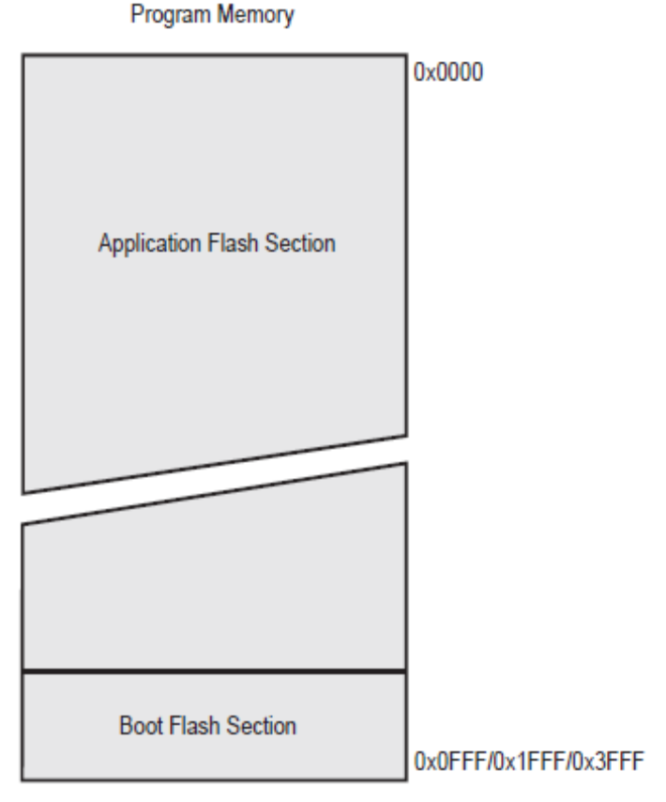
SRAM Data Memory
It shows how the ATmega328P SRAM Memory is organized. The ATmega328P is a complex microcontroller with more peripheral units than can be supported within the 64 locations reserved in the Opcode for the IN and OUT instructions. For the Extended I/O space from 0x60 - 0xFF in SRAM, only the ST/STS/STD and LD/LDS/LDD instructions can be used. The lower 768/1280/1280/2303 data memory locations address both the Register File, the I/O memory, Extended I/O memory, and the internal data SRAM. The first 32 locations address the Register File, the next 64 location the standard I/O memory, then 160 locations of Extended I/O memory, and the next 512/1024/1024/2048 locations address the internal data SRAM. The five different addressing modes for the data memory cover: Direct, Indirect with Displacement, Indirect, Indirect with Pre-decrement, and Indirect with Post-increment. In the Register File, registers R26 to R31 feature the indirect addressing pointer registers. The direct addressing reaches the entire data space. The Indirect with Displacement mode reaches 63 address locations from the base address given by the Y- or Z-register. When using register indirect addressing modes with automatic pre-decrement and post-increment, the address registers X, Y, and Z are decremented or incremented. The 32 general purpose working registers, 64 I/O Registers, 160 Extended I/O Registers, and the 2048 bytes of internal data SRAM in the ATmega328P are all accessible through all these addressing modes.

Figure . Data Memory Map
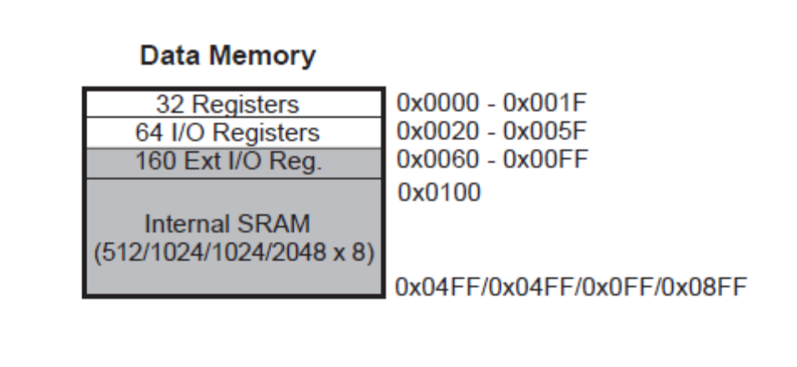
Data Memory Access Times
This section describes the general access timing concepts for internal memory access. The internal data SRAM access is performed in two clkCPU cycles as described in the below figure.
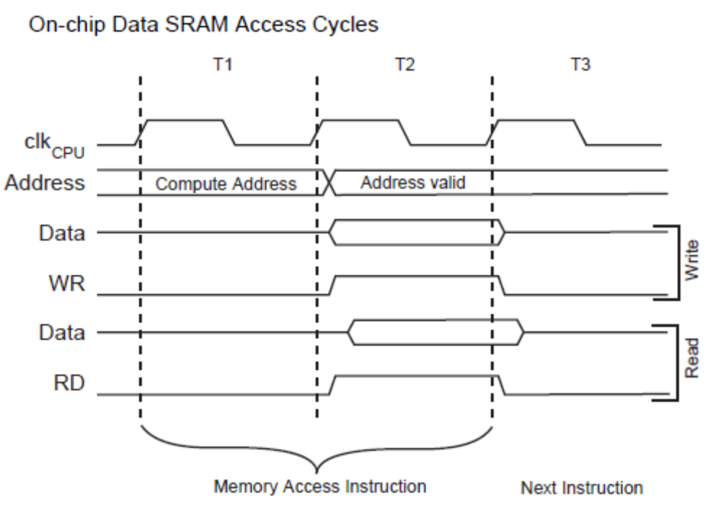

EEPROM Data Memory
The ATmega328P contains 1K bytes of data EEPROM memory. It is organized as a separate data space, in which single bytes can be read and written. The EEPROM has an endurance of at least 100,000 write/erase cycles. The access between the EEPROM and the CPU is described in the following, specifying the EEPROM Address Registers, the EEPROM Data Register, and the EEPROM Control Register.

EEPROM Read/Write Access
The EEPROM Access Registers are accessible in the I/O space. A self-timing function, however, lets the user software detect when the next byte can be written. If the user code contains instructions that write the EEPROM, some precautions must be taken. In heavily filtered power supplies, VCC is likely to rise or fall slowly on power-up/down. This causes the device for some period of time to run at a voltage lower than specified as minimum for the clock frequency used. In order to prevent unintentional EEPROM writes, a specific write procedure must be followed. Refer to the description of the EEPROM Control Register for details on this. When the EEPROM is read, the CPU is halted for four clock cycles before the next instruction is executed. When the EEPROM is written, the CPU is halted for two clock cycles before the next instruction is executed.

Preventing EEPROM Corruption
During periods of low VCC, the EEPROM data can be corrupted because the supply voltage is too low for the CPU and the EEPROM to operate properly. These issues are the same as for board level systems using EEPROM, and the same design solutions should be applied. An EEPROM data corruption can be caused by two situations when the voltage is too low. First, a regular write sequence to the EEPROM requires a minimum voltage to operate correctly. Secondly, the CPU itself can execute instructions incorrectly, if the supply voltage is too low. EEPROM data corruption can easily be avoided by following this design recommendation: Keep the AVR RESET active (low) during periods of insufficient power supply voltage. This can be done by enabling the internal Brown-out Detector (BOD). If the detection level of the internal BOD does not match the needed detection level, an external low VCC reset Protection circuit can be used. If a reset occurs while a write operation is in progress, the write operation will be completed provided that the power supply voltage is sufficient.

I/O Memory
All ATmega328P I/Os and peripherals are placed in the I/O space. All I/O locations may be accessed by the LD/LDS/LDD and ST/STS/STD instructions, transferring data between the 32 general purpose working registers and the I/O space. I/O Registers within the address range 0x00 - 0x1F are directly bit-accessible using the SBI and CBI instructions. In these registers, the value of single bits can be checked by using the SBIS and SBIC instructions. Refer to the instruction set section for more details. When using the I/O specific commands IN
and OUT, the I/O addresses 0x00 - 0x3F must be used. When addressing I/O Registers as data space using LD and ST instructions, 0x20 must be added to these addresses. The ATmega328P is a complex microcontroller with more peripheral units than can be supported within the 64 location reserved in Opcode for the IN and OUT instructions. For the Extended I/O space from 0x60 - 0xFF in SRAM, only the ST/STS/STD and LD/LDS/LDD instructions can be used. For compatibility with future devices, reserved bits should be written to zero if accessed. Reserved I/O memory addresses should never be written. Some of the Status Flags are cleared by writing a logical one to them. Note that, unlike most other AVRs, the CBI and SBI instructions will only operate on the specified bit, and can therefore be used on registers containing such Status Flags. The CBI and SBI instructions work with registers 0x00 to 0x1F only. The I/O and peripherals control registers are explained in later sections.

General Purpose I/O Registers
The ATmega48PA/88PA/168PA/328P contains three General Purpose I/O Registers. These registers can be used for storing any information, and they are particularly useful for storing global variables and Status Flags. General Purpose I/O Registers within the address range 0x00 - 0x1F are directly bit-accessible using the SBI, CBI, SBIS, and SBIC instructions.

